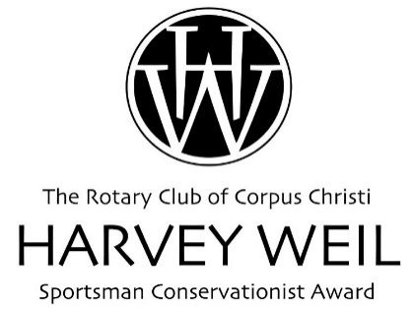
Deadline:
June 1, 2024

Lysa@rotarycc.com
www.rotarycc.com

2023 HARVEY WEIL GRANT REPORT

IRS regulations require grantors to obtain reports on the use of funds and compliance with the terms of the grant.

Please complete the following questions as they relate to your project or program. Future grant applications will not be considered without a timely completion of this report.

- Name of Lead Investigator/ Program Manager:

- Name of organization:

- Program/Project name:

- Was the program/project modified, (i.e., timing, objectives, etc.) since the proposal was presented to the Harvey Weil Sportsman Conservationist Award? If yes, explain.

- What were your goals and objectives?

- Were your goals and objectives met? In instances in which they were not met substantially, what were the reasons?

- What were the major findings or accomplishments of your program/project?

- If appropriate, list other institutions or organizations that you collaborated with on the project, program.

- Please give your overall assessment of the impact of the program/project on your organization and on those people it was designed to serve. Has the program/project led to the development of similar ones in other organizations? In short, did it really make a difference?

- Designate where any dissertation or thesis can be accessed by the Rotary Club of Corpus Christi, if applicable (e.g., website, publication source, etc.).

- Provide 2 - 3 digital images of project activities.

- Provide evidence of full and proper credit to The Rotary Club of Corpus Christi Harvey Weil Sportsman Conservationist Award for support of this research in all publications and other appropriate forums.

- Provide project/program financial information below. Note: Grant does not cover indirect/overhead expenses

Amount Awarded:

Program/Project Dates:

Expenditures | Actual
Salaries: Wages & Benefits

Equipment

Supplies

Travel

Other (list)

Total

I hereby certify the above statement to be correct and that funds were utilized in accordance with the purpose of the grant.

________________________ ________________
Lead Investigator/ Program Manager Signature Date

