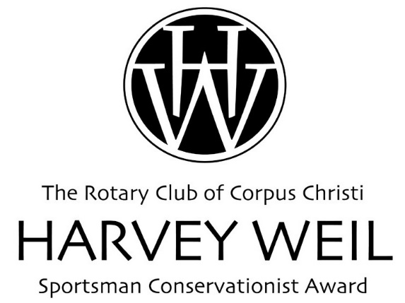
Deadline to Submit:
July 10, 2023
Nominating Form
Sportsman Conservationist of the Year Award

NOMINEE

Nominee: ____________________________________________________
First M.I. Last

Home Address: ________________________________________________
Street

________________________________________________
City State Zip

Day Time Phone #: _______________ Email: ______________________

Current Occupation (If applicable): ________________________________

Name of Nominee’s Firm: _______________________________________

Firm’s Address: _______________________________________________ Street City State Zip

NOMINATOR

Name of person or group submitting nomination:

________________________________________________________
Name Date

________________________________________________________
Email Phone

NOMINATING STATEMENT

On no more than two 8 ½ X 11 single spaced typewritten pages, describe why your nominee should be chosen as the recipient of the Harvey Weil Sportsman Conservationist Award. Please include a bio if available.

Criteria for the Harvey Weil Sportsman Conservationist Award:

- The nominee will be a man or a woman who has made significant contributions to conservation, particularly of wildlife habitat and/or marine fisheries.
- The nominee is not a conservationist by profession.
- The nominee should be a sportsman.
- The nominee may reside anywhere in the world and have worked in conservation of wildlife or marine fisheries worldwide.
- A committee comprised of well-known conservationists, Rotary members and Steering Committee members will choose the winner.
- A winner will be chosen annually.
- The winner will exemplify the same qualities that Harvey Weil possessed.
- The winner does not have to be a Rotarian.

Please send nominations by July 10, 2023 to:

Rotary Club of Corpus Christi
Attn: Lysa Chapman
921 N. Chaparral, Ste. 210
Corpus Christi, TX 78401

Or by email to: lysa@rotarycc.com or fax to: 361.888.5579

If you have any questions, please call Lysa Chapman at 361.882.8672

