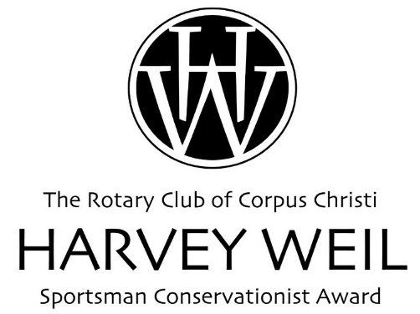
Please contact Lysa Chapman
with any questions.
361.882.8672, lysa@rotarycc.com
Deadline:
Oct. 6, 2017 at noon

GRANT APPLICATION FORM - 2018 Grant Cycle
(Please address all questions.)
__________________________________________________________________

- Program/project contact information:
Check the category that applies to your project:

Category:
____Hunting & Fishing Recreation
____Fisheries Management
____Wildlife Management
____Conservation Science
____Conservation Education

Name of Lead Investigator/Program Manager:

Name of organization:

Physical address:

Mailing address (include mail code if applicable):

Email address:

Telephone number:

Fax number:

Name of Grant Manager or Authorized Representative, if appropriate:

Email address for Grant Manager or Authorized Representative:
*Note: Grant notifications will be sent electronically

- Applicants must be classified as a 501(c)3 or its equivalent. Provide Federal Tax ID number or IRS Letter of Determination

- Program/project name:

- Implementation and conclusion dates of program/project:

- Amount requested:

- Brief program/project summary (100 words or less)

- Brief history and mission statement of the grant seeking organization (150 words or less):

- Describe the importance or value of the research or education program and its impacts on marine and wildlife species and their habitats. How will the work support recreational hunting and fishing, if appropriate? (150 words or less):

- List the goals and objectives of the program/project. (100 words or less):

- Describe the methods to be used in the program/project. (150 words or less):

- Does the program/project have the potential for application throughout the field of hunting, fishing, and/or conservation of natural resources? If so, how? Or is it only applicable to a narrow field or locality? (100 words or less):

- Attach vitae or resume of Lead Investigator/ Program Manager of the program/project.

- Financial information:

- Current Organization or Department Annual Operating Budget: $_______________

b. Total budget for this project: $_______________

c. Other funds on hand or pending for this particular project
(identify internal and external sources): . $_______________

- How will the funds be used? Note: Grant funds may not be used for indirect/overhead costs. (100 words or less)

Should the Rotary Club of Corpus Christi Harvey Weil Sportsman Conservationist Award grant funds for this project, the undersigned agrees:

- To spend funds by May 1, 2019
- To submit an electronic grant report by June 1, 2019 including documentation of how Harvey Weil funds were used;
- To designate where any dissertation or thesis can be accessed by the Rotary Club of Corpus Christi, if applicable (e.g., website, publication source, etc.).
- To provide 2 - 3 digital images of project activities.
- To provide evidence of full and proper credit to The Rotary Club of Corpus Christi Harvey Weil Sportsman Conservationist Award for support of this research in all publications and other appropriate forums.

______________________________ ___________________________
Signature of Lead Investigator/ Signature of Authorized Program Manager Organization Officer or Board Officer

Submittal Date: _______________________________

Submit completed applications by email or mail to:

Lysa Chapman

Rotary Club of Corpus Christi
921 N. Chaparral, Ste. 210
Corpus Christi, TX 78401

lysa@rotarycc.com
361.886.8672

